Packet Tracer – Troubleshooting Inter-VLAN Routing

1. Topology

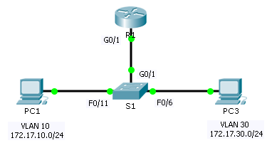

1. Addressing Table

|  |  |  |  |  |  |
| --- | --- | --- | --- | --- | --- |
| Device | Interface | IP Address | Subnet Mask | Default Gateway | VLAN |
| R1 | G0/1.10 | 172.17.10.1 | 255.255.255.0 | N/A | VLAN 10 |
| G0/1.30 | 172.17.30.1 | 255.255.255.0 | N/A | VLAN 30 |
| PC1 | NIC | 172.17.10.10 | 255.255.255.0 | 172.17.10.1 | VLAN 10 |
| PC3 | NIC | 172.17.30.10 | 255.255.255.0 | 172.17.30.1 | VLAN 30 |

1. Objectives

Part 1: Locate Network Problems

Part 2: Implement the Solution

Part 3: Verify Network Connectivity

1. Scenario

In this activity, you will troubleshoot connectivity problems caused by improper configurations related to VLANs and inter-VLAN routing.

1. Locate the Network Problems

Examine the network and locate the source of any connectivity issues.

* Test connectivity and use the necessary **show** commands on to verify configurations.
* List all of the problems and possible solutions in the **Documentation Table**.

1. Documentation Table

|  |  |
| --- | --- |
| Problems | Solutions |
|  |  |
|  |  |
|  |  |
|  |  |
|  |  |
|  |  |

1. Implement the Solutions

Make changes according to your recommended solutions.

1. Verify Network Connectivity

Verify the PCs can ping other PCs and R1. If not, continue to troubleshoot until the pings are successful.

1. Suggested Scoring Rubric

Packet Tracer scores 60 points. Completing the **Documentation Table** is worth 40 points.